Check list when creating an new environment for MCAS

1: Application Server

This is sever where our website host along with supporting services, minimum requirement for this server should be

* Dot Net Framework 4.0
* IIS 7.0 or above

2: Database Server

This is sever where our database resides along with supporting services, minimum requirement for this server should be

* SQL Server 2008 R2 or above
* Microsoft Access Database Engine 2010 64 bit

3: Public URL so that client can access this environment

Note: All these requirement are fulfilled by IT team and client support. There may be still some activities needed to perform by Configuration Management team in order to build complete and effective environment.

**Application Server**

* Configure IIS for web application apply impersonation user
* Put the Released folder (provided by India Team-“**MCAS.Web**” folder Under “**MCAS _Release_03042015**”) at some location on the Application Server and Map through IIS according to the given screen shot below.

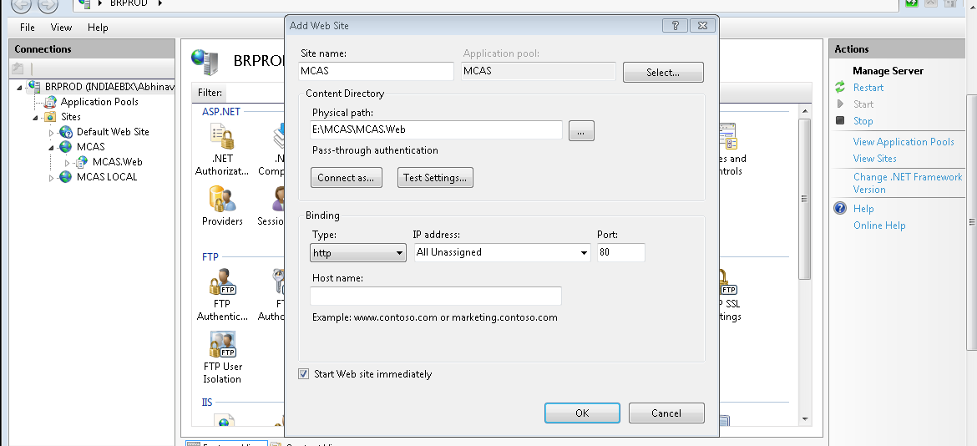

* Configure Upload directory for File Server by creating virtual directory (“Uploads”) default at Application path as shown below .

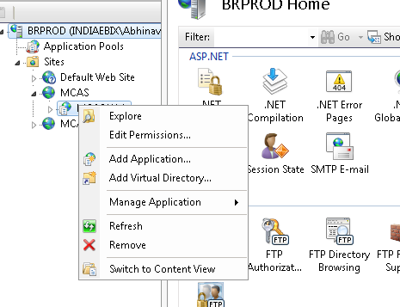

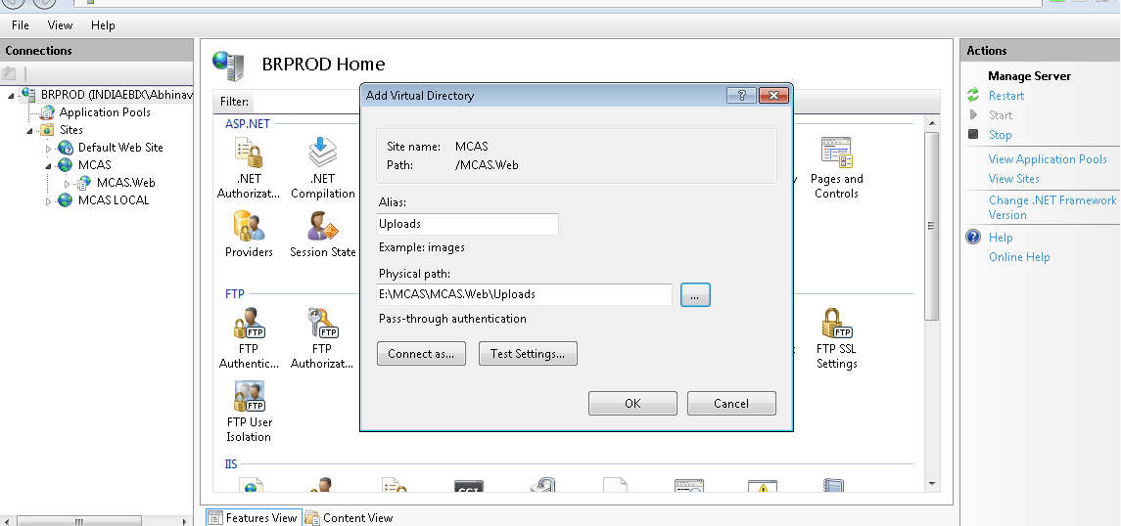

Database Server

* Configure SQL Server 2008 R2.
* Restore database or execute Scripts (to be provided by India Team).
* Remember credentials to login on Sql server.

**Execute Provided Scripts (DB scripts under “DB Scripts” folder)**

Execute scripts provided in “DB Script” folder of Release in order of their name like:

1. 1CreateDB.sql –

Note: Before executing this script, please verify the DB file Path. You may need to verify the path mentioned for FILENAME for NAME= N’MCAS_UAT and NAME=N’MCAS_UAT_log. Like:

(FILENAME = N'C:\Program Files\Microsoft SQL Server\MSSQL10_50.MSSQLSERVER\MSSQL\DATA\MCAS_UAT.mdf')

1. 2CreateTableAndProc-Schema.sql
2. 3CreateLookUpTable.sql
3. 4ScriptForDefaultGroupAndUser .sql
4. 5CreateMenusScript.sql

**SQL Configuration and JOBS**

**File Upload Configuration**

**1. Update "FileServerPath" column of Table "**MNT_SYS_PARAMS" in Database. put FileServerPath in this Column.

Like: "\\192.168.91.18\". this may be IP or Name of fileServer.

**2**. Update Key "UploadFolder" in web.config file. set it Name of Shared upload folder on the fileServer.

**3. File Upload Job**

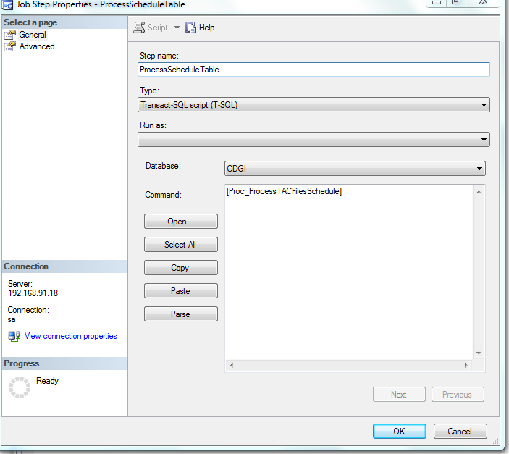

**Send Mail Job**

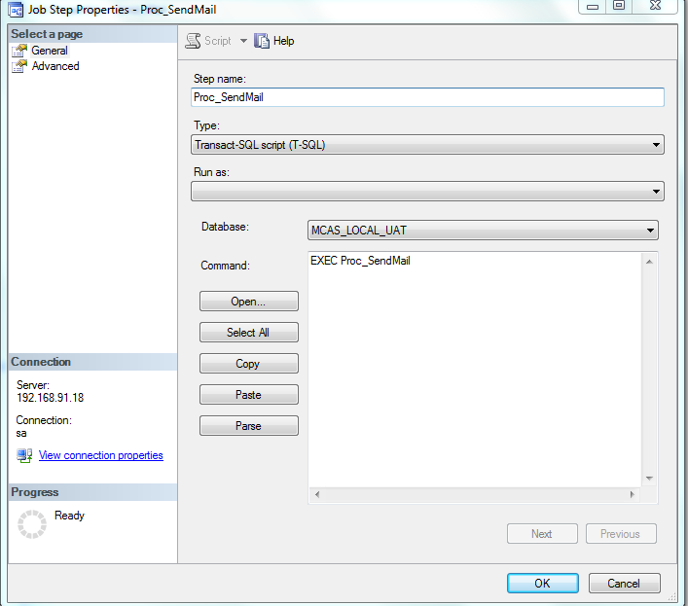

**Changes in Web.config**

After Configure Application and File Server and Sql Server, Web Config file of Application need to be changed

Open Web.Config File from the Application Path (Under MCAS.Web in this case) in edit mode and update Yellow highlighted

<add key="ExceptionConString" value="Data Source=255.255.255.255;Initial Catalog=ggg;User ID=sa;Password=ggg;"/>

<connectionStrings>

<add name="DefaultConnection" connectionString="Data Source=255.255.255.255;Initial Catalog=aspnet-MCAS-20140402153148;Integrated Security=SSPI" providerName="System.Data.SqlClient" />

<add name="MCASEntities" connectionString="metadata=res://*/MCASEntities.csdl|res://*/MCASEntities.ssdl|res://*/MCASEntities.msl;provider=System.Data.SqlClient;provider connection string=&quot;Data Source=255.255.255.255;Initial Catalog=DBName;Persist Security Info=True;User ID=gg;Password=ggg;MultipleActiveResultSets=True;Application Name=EntityFramework&quot;" providerName="System.Data.EntityClient" />

</connectionStrings>

Changes to be made

Data Source: Database server IP

Initial Catalog: Database Name

ID : Database login Username

Password: Database login Password

**Default User to login in MCAS Application**

User:Admin

Password:1234